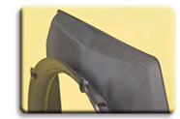
  NexPrene TPEs
  Automotive and General Purpose

The NexPrene® 1000 series contains materials designed for use in automotive applications and as general-purpose elastomers. Grades in this series are available in a range of hardness from 25 Shore A to 50 Shore D.
These materials have been developed as replacements for thermoset elastomers such as polychloroprene or EPDM. NexPrene materials provide the elastomeric properties of thermoset products, including resistance to compression set and oil swell.
These cost-efficient TPEs can be easily recycled, and they are designed to be processed using conventional equipment and methods.
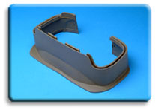
NexPrene® 1000 series — Technical Data
Products in this series are identified by their hardness ratings in the last three positions of the product name. For example, NexPrene 1055A TPE has a nominal hardness that measures 55 Shore A. For performance properties of one of the materials in the 1000 series, click on the product designation below:
NexPrene 1024A  NexPrene 1035A  NexPrene 1040A  NexPrene 1045A | NexPrene 1055A  NexPrene 1064A  NexPrene 1067A  NexPrene 1075A | NexPrene 1080A  NexPrene 1087A  NexPrene 1040D  NexPrene 1050D

